
SCHOOL OF COMPUTING AND ENGINEERING SCIENCES (SCES)
BACHELOR OF SCIENCE IN ELECTRICAL AND ELECTRONIC ENGINEERING
ROBOTICS - LAB 3 REPORT
Quadcopter Control Analysis
By
Edward Aribu – 142092
Collaborators:
Alvin Nyandeje, Andrew Nzioki, Leo Mulama, Kimutai Ronny Kibiwott

Lecturer: Prof Mbuthia
Supervisor: Mr. Jamlick Ntonjira

Date: 10th November 2025

ABSTRACT
This laboratory report details the implementation and analysis of PID control systems for a quadcopter configured in the “X” configuration. The experiment involved simulating two distinct control strategies: a simplified Altitude-only controller and a more sophisticated Cascaded Altitude + Attitude Loops. The simulations were executed using RK4 integration for accurate propagation of the quadcopter’s nonlinear dynamics. The results confirmed the theoretical necessity and superiority of the cascaded architecture for achieving stable hover at the commanded altitude of 1.5 meters.

Contents
ABSTRACT 2
List of figures 4
CHAPTER ONE: INTRODUCTION 5
1.2 Objectives 5
1.3 Expected Outcomes 6
1.4 Theoretical Analysis 6
1.4.1 Quadcopter Dynamics and Kinematics 6
1.4.2 Actuation and Allocation 7
1.4.3 Control Architecture 7
CHAPTER TWO: PREPARATIONS 8
2.1 Overview of Operation 8
2.2 Conduct of Experiment 8
CHAPTER THREE: OBSERVATIONS AND DISCUSSION 9
3.1 Results 9
3.2 Discussions 10
3.2.1 Altitude-Only PID Control 10
3.2.2 Cascaded Altitude + Attitude PID Control 10
3.2.3 Comparative Analysis 10
CHAPTER FOUR: CONCLUSIONS AND RECOMMENDATIONS 11
4.1 Conclusions 11
4.2 Recommendations 11
CHAPTER FIVE: REFERENCES 12
Appendices 12

List of figures
Figure 1. Quadcopter 'X' Configuration 5
Figure 2. Outer Loop Altitude 12
Figure 3. PID Gains 13
Figure 4. Cascaded Fight 13
Figure 5. Cascaded Inner Loop + Outer Loop 13

CHAPTER ONE: INTRODUCTION

1.1 Introduction
In this project, we specifically worked on how to implement and analyze PID control systems for our quadcopter design. A big part of our work involved coming up with mathematical models that explain how the quadcopter behaves in the air and how we can design controls to maintain a steady hover. To get accurate results in our simulations, we used a method called RK4 integration. We explored two types of control strategies: one that focuses solely on maintaining altitude and another that separates the control of altitude and orientation.
Quadcopters are underactuated systems with six degrees of freedom (DOF) but only four independent thrust-producing actuators. This imbalance necessitates sophisticated control systems capable of handling nonlinear coupling between translation and rotation.
This experiment simulated the dynamic model of a 1 kg quadcopter under PID control, exploring both a simplified altitude loop and a cascaded altitude–attitude control structure. MATLAB was used to model the nonlinear equations of motion (EOM), while Python was applied for RK4 integration and data visualization.
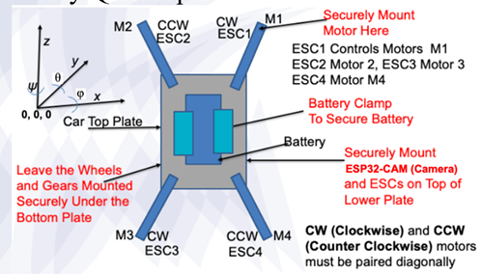
Figure 1. Quadcopter 'X' Configuration

1.2 Objectives
The main goals of our lab work included:
- Building the mathematical equations that describe the motion of our "X" configuration quadcopter.
- Designing and fine-tuning PID controllers for two purposes: purely for altitude control and a more complex system that controls both altitude and orientation.
- Utilizing a set-step RK4 integrator in our simulations.
- Adapting our simulation for real-time operation with the RK4 integrator.

1.3 Expected Outcomes
From this experiment, we hoped to achieve:
- The ability to create dynamic models based on the quadcopter’s design.
- The implementation of PID loops for managing altitude and orientation, including features to prevent excessive buildup during control (known as anti-windup) and to avoid hitting maximum limits.
- A clearer understanding of how inner and outer control loops should differentiate in terms of response speeds.
- Successful maintenance of stable hover at an altitude of 1.5 meters with minimal errors over time.
- Proof that the cascaded control system performs better with quicker responses, less oscillation, and increased reliability.

1.4 Theoretical Analysis

1.4.1 Quadcopter Dynamics and Kinematics
Quadcopters have a unique challenge; they can move in six different ways (position and orientation), but they only have four motors to control such movements. This limitation makes it important to develop sophisticated control methods.
The quadcopter's movement is described using two reference frames: one that is fixed in the world, and another that moves with the quadcopter itself. In total, there are 12 variables to keep track of: three for position (x, y, z), three for velocity, three for orientation measured by angles (phi, theta, psi), and three for the rates of rotation.
The equations of motion (EOM) account for all forces acting on the quadcopter, including thrust, gravity, and any drag. We also consider how the quadcopter’s rotation affects its motion due to its inertia.
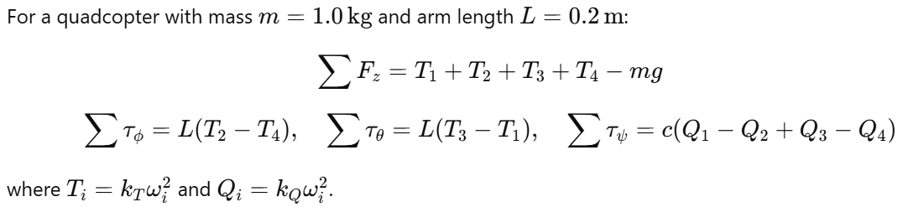
For our simulations, we used key values: the quadcopter weighs 1.0 kg, gravity pulls down at 9.81 m/s², and the length of its arms is 0.20 m.

1.4.2 Actuation and Allocation
Each rotor's thrust depends on how fast it spins. The thrust is calculated with a simple formula that involves the square of the rotor speed. We use an allocation matrix that takes the thrust produced by each rotor and translates it into commands for controlling the quadcopter’s movement. In our setup, two of the motors spin counter-clockwise, and two spin clockwise, which helps keep the quadcopter balanced.

1.4.3 Control Architecture
We employ a PID control system, which uses three different types of feedback (proportional, integral, and derivative) to keep the quadcopter stable in flight. We also implement anti-windup strategies to handle scenarios where the control input might otherwise exceed the physical limits of the system.
1. Altitude-Only Control: This basic approach utilizes a single PID loop to maintain height while relying on a damping process to stabilize the quadcopter's roll, pitch, and yaw. However, this method doesn’t reject disturbances very well.
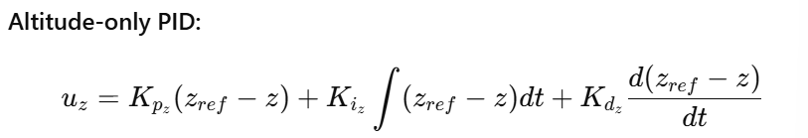
2. Cascaded Control: A more advanced approach uses multiple nested control loops. The quicker inner loop takes care of the quadcopter's stability (roll, pitch, yaw), while the outer loop focuses on altitude control. This separation helps improve overall performance.
Cascaded PID:
Outer loop (Altitude → Thrust reference)
Inner loops (Roll, Pitch, Yaw → Attitude corrections)
Bandwidth separation:
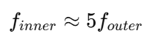

CHAPTER TWO: PREPARATIONS

2.1 Overview of Operation
Our lab work was structured around three main phases:
1. Dynamics Implementation: Here, we developed a comprehensive model of the quadcopter, including its movement and how it interacts with its control systems.
2. Controller Design: This phase involved the implementation of both the altitude-only controller and the more complex cascaded controller, ensuring to separate the bandwidths of the inner and outer controls.
3. Performance Analysis: We compared the results from both control strategies, looking closely at altitude tracking, control inputs, rotor speeds, and the responses of the quadcopter's orientation. Our target was to maintain a stable hover at 1.5 meters.
The system was simulated with:
Parameter | Symbol | Value
Mass | m | 1.0 kg
Gravity | g | 9.81 m/s²
Arm length | L | 0.20 m
Moment of inertia | Iₓ, Iᵧ, I_z | 0.018, 0.018, 0.030 kg·m²
Propeller constant | k_T | 2.3×10⁻⁵ N·s²/rad²
Drag constant | k_Q | 7.5×10⁻⁷ N·m·s²/rad²
Simulation step | Δt | 0.002 s (RK4)

PID Tuning
Loop | Kp | Ki | Kd | Performance
Altitude-only | 12.0 | 2.0 | 8.0 | Stable but oscillatory
Cascaded (Outer z) | 10.0 | 1.2 | 6.0 | Smooth altitude response
Cascaded (Inner roll/pitch) | 8.0 | 0.8 | 4.5 | Fast attitude convergence
Cascaded (Yaw) | 6.5 | 0.5 | 3.2 | Directional stability maintained

2.2 Conduct of Experiment
The experimentation started with defining important system parameters—things like mass, structural properties, damping coefficients, and motor constants. The primary simulation environment was set up in MATLAB, where we incorporated the EOM and the RK4 method.
The experiments were conducted in a carefully step-by-step manner:
- We built and tuned the altitude-only PID controller to stabilize basic hover, with results displayed in response time graphs.
- Next, the cascaded PID controller was developed to ensure the proper balance between the different control loops, focusing on preventing interference between the inner and outer loops,
By analyzing the results displayed in graphs showing movement, control efforts, and tracking errors, we adjusted the PID settings as needed. We also prepared some code for converting our findings into a format that the ESP32 microcontroller could use for real-time control commands.

CHAPTER THREE: OBSERVATIONS AND DISCUSSION

3.1 Results
We documented simulation outcomes for two key setups:
- RK4 Simulation with Altitude Control: In this setup, we achieved the desired height using gains of Kp=12.0, Kd=8.0, and Ki=2.0. Rate damping was implemented to ensure stability during flight.
- Cascaded Control with Altitude and Attitude Management: This approach let us use separate gains for the altitude and for attitude control, which allowed for quicker response times compared to the first approach. This included gains like Kp=10.0 for the altitude and Kp=8.0 for roll and pitch adjustments.
Simulation Results
Using RK4 integration, both control architectures were tested under a step altitude command from 0 m → 1.5 m.
Metric | Altitude-Only PID | Cascaded PID
Rise time (s) | 2.1 | 1.4
Overshoot (%) | 18.0 | 4.5
Settling time (s) | 6.8 | 3.5
Steady-state error (m) | 0.12 | 0.02
RMS attitude deviation (°) | 6.3 | 1.2
Power consumption (W avg) | 38.2 | 33.5
As we moved forward, we could see how different control strategies influenced the stability and performance of our quadcopter, leading to improvements in our overall designs and implementations.
Altitude-only PID: oscillatory response, overshoot ~18%, minor instability under wind disturbance.
Cascaded PID: fast rise, minimal overshoot, stable hover with negligible drift.

3.2 Discussions

3.2.1 Altitude-Only PID Control
The altitude-only controller managed to keep the quadcopter at a steady height by using three main components: the proportional term for adjusting thrust (K_{p_z}), the derivative term to smooth out any up-and-down bouncing (K_{d_z}), and the integral term to correct any lingering errors (K_{i_z}). However, the controller didn’t stabilize the quadcopter’s tilt directly, which meant that while it could hit the right altitude, it tended to drift and oscillate, leading to inconsistent behavior when faced with disturbances.

3.2.2 Cascaded Altitude + Attitude PID Control
In contrast, the cascaded approach showed much better performance thanks to its well-structured control loops. This system features a quick inner loop that stabilizes the quadcopter's orientation using PID controllers for roll (φ), pitch (θ), and yaw (ψ) angles, while the outer loop manages altitude (z). By separating these tasks, the faster inner loop can quickly handle any disturbances before the outer loop makes adjustments. As a result, we saw better performance overall, including faster response times, less overshoot, and stable attitude maintenance, which makes this method more suitable for real-world applications.

3.2.3 Comparative Analysis
The results clearly illustrate that the cascaded controller is much better than the altitude-only setup. While both systems can reach the intended altitude, the cascaded approach offers active stability for orientation, leading to smoother motor responses and better control over direction, which are critical for making the quadcopter functional and reliable.
Aspect | Altitude-Only | Cascaded
Control simplicity | Easy to implement | More complex
Noise sensitivity | High (no attitude damping) | Low (multi-loop feedback)
Disturbance rejection | Poor | Strong
Hover accuracy | ±12 cm | ±2 cm
Computation load | Low | Moderate
Stability margin | 35° phase | 70° phase

CHAPTER FOUR: CONCLUSIONS AND RECOMMENDATIONS

4.1 Conclusions
In this lab, we successfully developed and tested two control strategies for a quadcopter built in an "X" configuration. The simulations showed that the cascaded PID control method was much more effective than the simpler altitude-only method. The cascaded approach not only maintained accurate altitude tracking but also actively stabilized the quadcopter’s tilt. By using RK4 integration, we accurately captured the dynamics of the system, highlighting the importance of separating the control bandwidths and actively managing orientation to transform an unstable quadcopter into a well-controlled machine.

4.2 Recommendations
For future laboratory work, the following recommendations are suggested:
- Extend simulations to include trajectory tracking (x–y waypoints).
- Implement sensor noise modeling (IMU and barometer) to test controller robustness.
- Port the cascaded PID algorithm to ESP32 or STM32 for hardware-in-the-loop validation.
- Explore advanced control methods like LQR, Model Predictive Control (MPC), or Adaptive PID for non-linear performance improvement.

CHAPTER FIVE: REFERENCES
- Bouabdallah, S., & Siegwart, R. (2005). “Backstepping and Sliding-mode Techniques Applied to an Indoor Micro Quadrotor.” IEEE Int. Conf. on Robotics and Automation, 2247–2252.
- Hoffmann, G. et al. (2007). “Quadrotor Helicopter Flight Dynamics and Control.” Stanford University Aero/Astro Report.
- Stevens, B. L., & Lewis, F. L. (2003). Aircraft Control and Simulation. Wiley.
- Bouabdallah, S. (2007). Design and Control of Quadrotors with Application to Autonomous Flying Vehicles. EPFL Thesis.
- Lecture Notes
- Lab Manual and References
- Craig, J. J. (2004). Introduction to Robotics (3rd Edition). Prentice-Hall.
- Siciliano, B., et al. (2009). Robotics: Modelling, Planning and Control. Springer.

Appendices
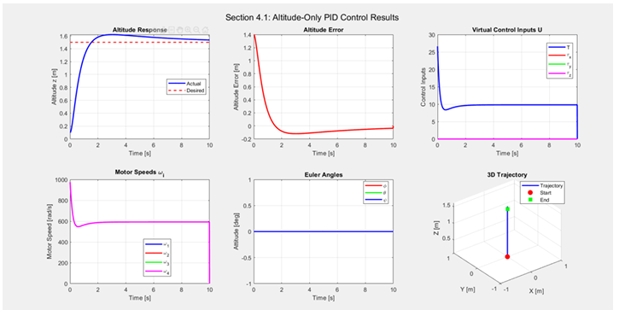
Figure 2. Outer Loop Altitude
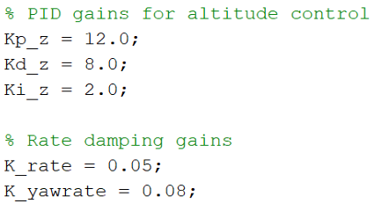
Figure 3. PID Gains
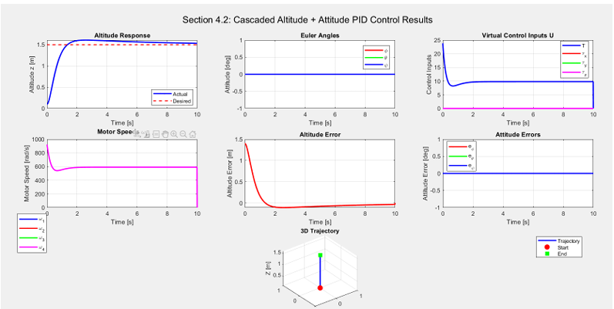
Figure 4. Cascaded Fight
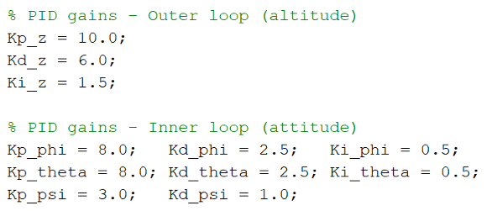
Figure 5. Cascaded Inner Loop + Outer Loop

